APP PARALLEL AND CONCURRENT PROGRAMMING

**Question 1: Create Simple Client Server Application using TCP Socket where server issue a command**

**which will be executed at the client slide as a process of remote command execution**

**Solution:**

**Client.py**

import socket

def client_program():

host = socket.gethostname()

port = 100

client_socket = socket.socket()

client_socket.connect((host, port))

message = input("Enter massage for server: ")

while message.lower().strip() != 'bye':

client_socket.send(message.encode())

data = client_socket.recv(1024).decode()

print('Message from server: ' + data)

message = input(" Enter massage for server: ")

client_socket.close()

if __name__ == '__main__':

client_program()

**Server.py**

import socket

def server_program():

host = socket.gethostname()

port = 100

server_socket = socket.socket()

server_socket.bind((host, port))

server_socket.listen(2)

conn, address = server_socket.accept()

print("Client Connection from: " + str(address))

while True:

data = conn.recv(1024).decode()

if not data:

break

print("Message from client: " + str(data))

data = input(' Enter message for client: ')

conn.send(data.encode())

conn.close()

if __name__ == '__main__':

server_program()

**SCREENSHOTS:**

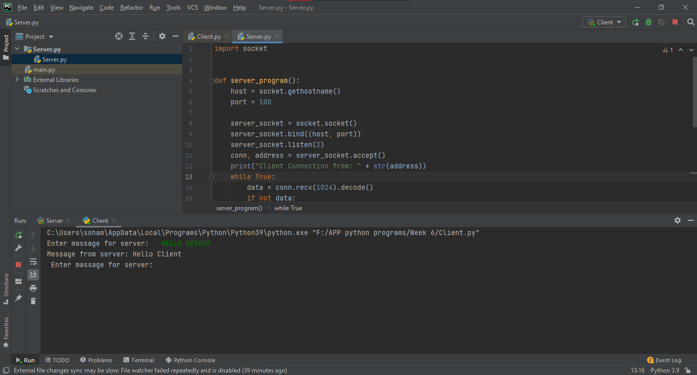

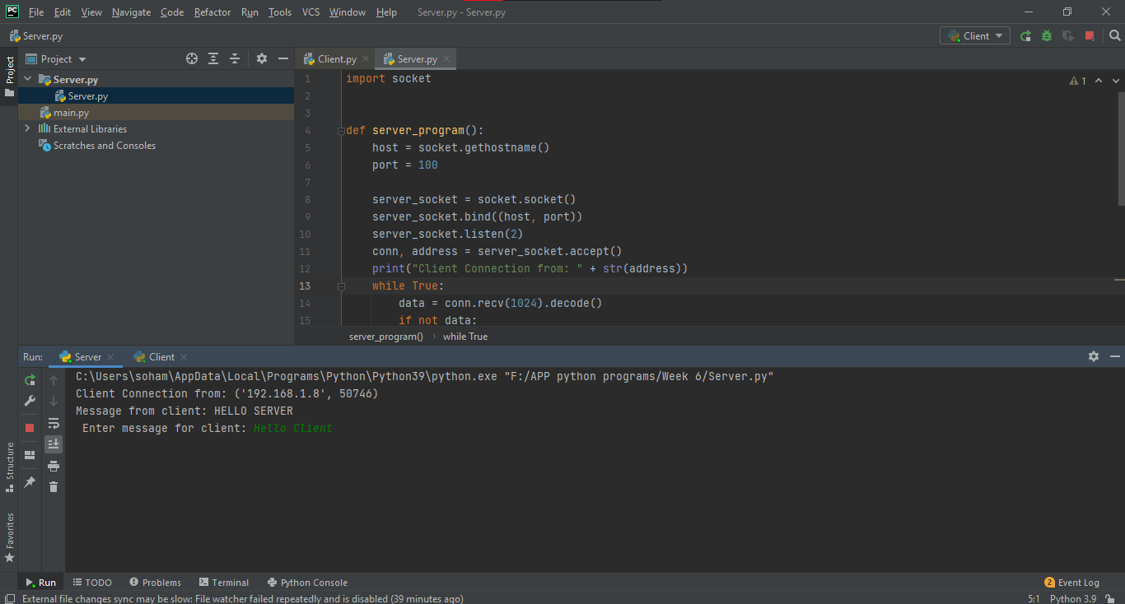

Done by: Soham Sakaria

RA1911003010246